

**INLIGHNTECH | InlighnX Global Private Limited**

**INTERNSHIP PROJECT REPORT**

**Project Title:**  
Information Gathering Challenge

**Submitted by**:  
**Rohan Singh Chouhan**  
Cybersecurity Intern

**Submitted to:**  
[Mentor/Supervisor Name & Designation]  
INLIGHNTECH | InlighnX Global Private Limited

Date of Submission:  
5th January 2026

## **1. Basic Information**

**Target Details**

* **Domain Name:** inlighntech.com
* **Resolved IP Address:** 185.151.30.222
* **Hosting Provider:** 20i Global Cloud Platform (Anycast CDN), United Kingdom
* **Registrar:** NameCheap, Inc.
* **Name Servers:**
  + ns1.stackdns.com
  + ns2.stackdns.com
  + ns3.stackdns.com
  + Ns4.stackdns.com
* **DNSSEC Status:** Unsigned
* **Registrant Information:** Protected via *Withheld for Privacy ehf*, Reykjavik, Iceland

### **Findings and Interpretation**

The WHOIS lookup revealed that the domain *inlighntech.com* is registered through **NameCheap, Inc.**, with privacy protection managed by **Withheld for Privacy ehf** in Reykjavik, Iceland.  
 The domain was **created on November 7, 2024** and is set to **expire on November 7, 2025**.  
 The DNS management is handled by **StackDNS**, as indicated by the listed name servers.

A DNS lookup (dig) resolved the domain to the IP address **185.151.30.222**, which belongs to the **20i Global Cloud Platform** in the **United Kingdom**. The IP WHOIS record describes it as an **Anycast CDN subnet**, suggesting that the target uses a **content delivery network** for global performance and redundancy.

Additionally, DNSSEC is **not implemented** (status: *unsigned*), meaning DNS responses are not cryptographically validated—an observation worth noting for security posture.

**Commands Used :**

|  |
| --- |
| 1. whois inlighntech.com 2. dig +short inlighntech.com 3. whois $(dig +short inlighntech.com | head -n1) |

* **Figure** **1.1 :** WHOIS output displaying registrar and registration details.

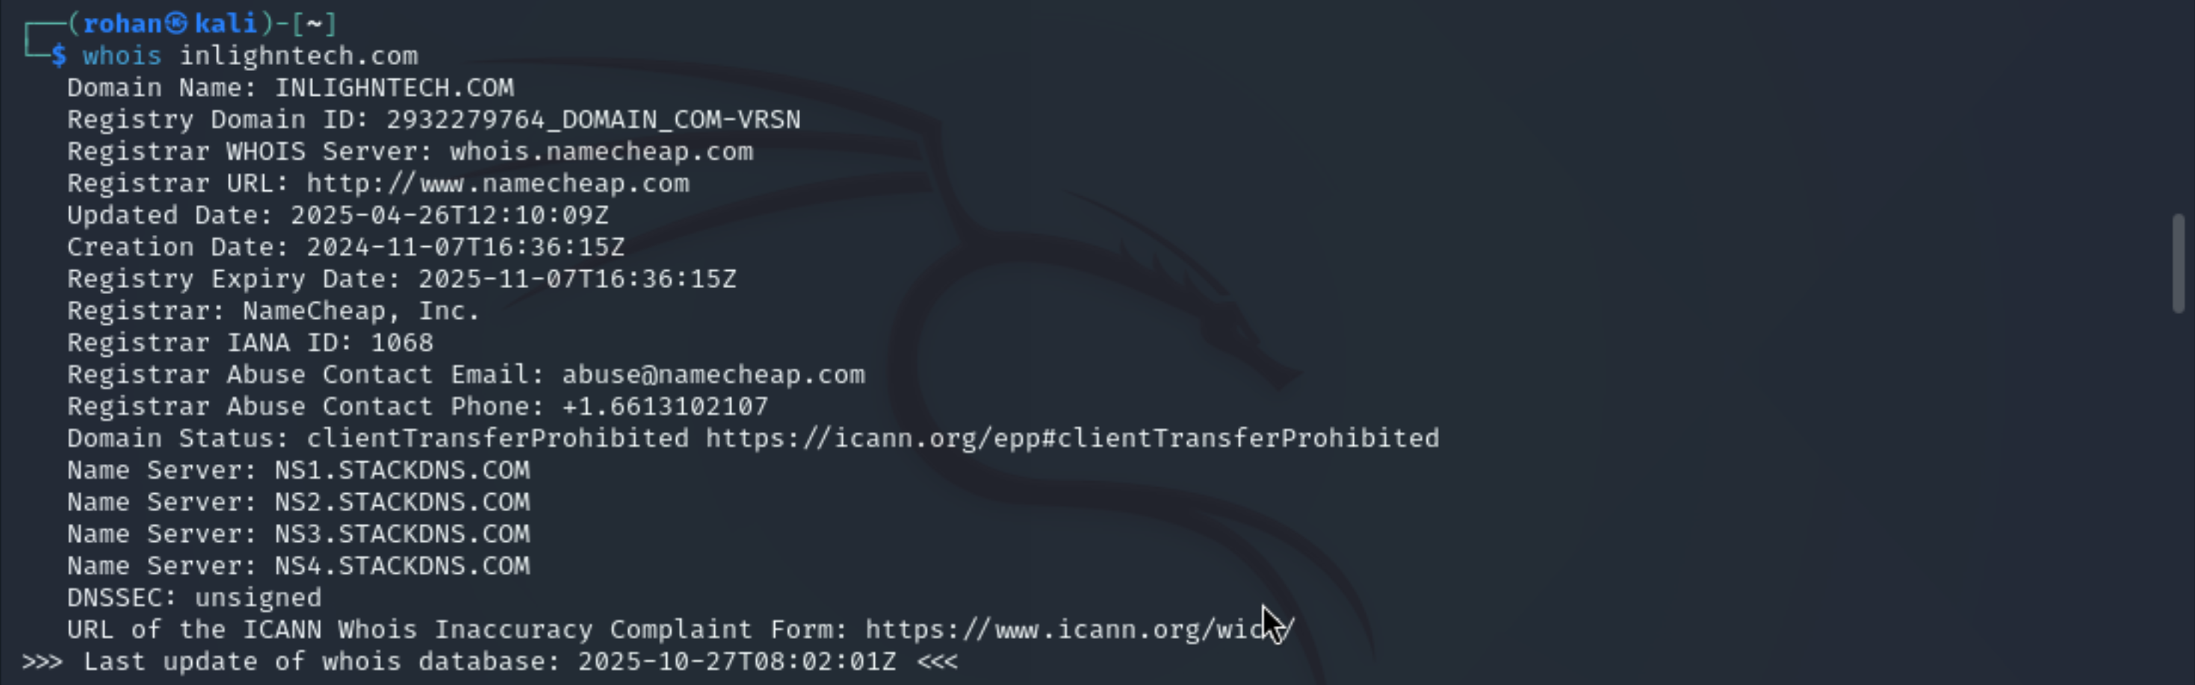

* **Figure** **1.2 :** DIG command result showing the resolved IP address.

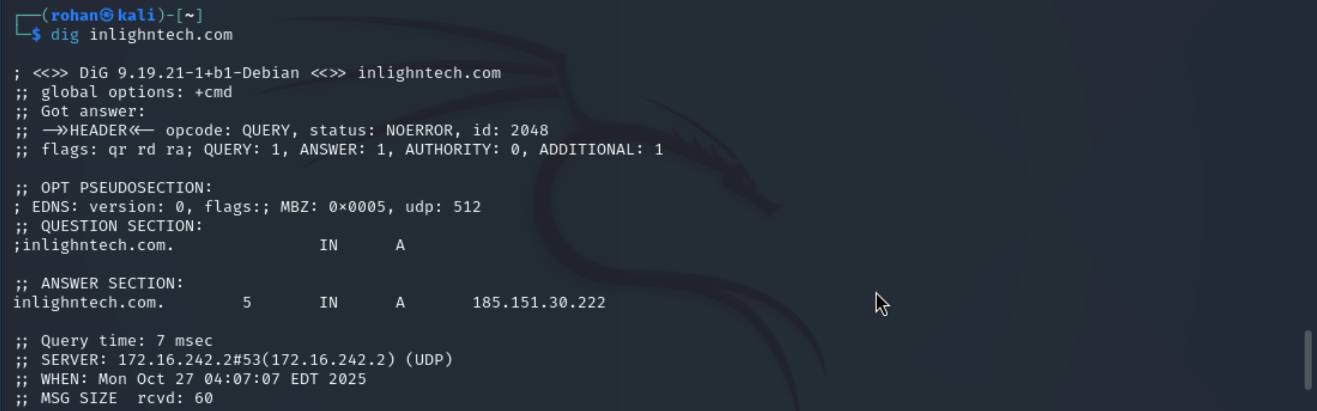

* **Figure** **1.3 :** IP WHOIS result confirming hosting provider and location.

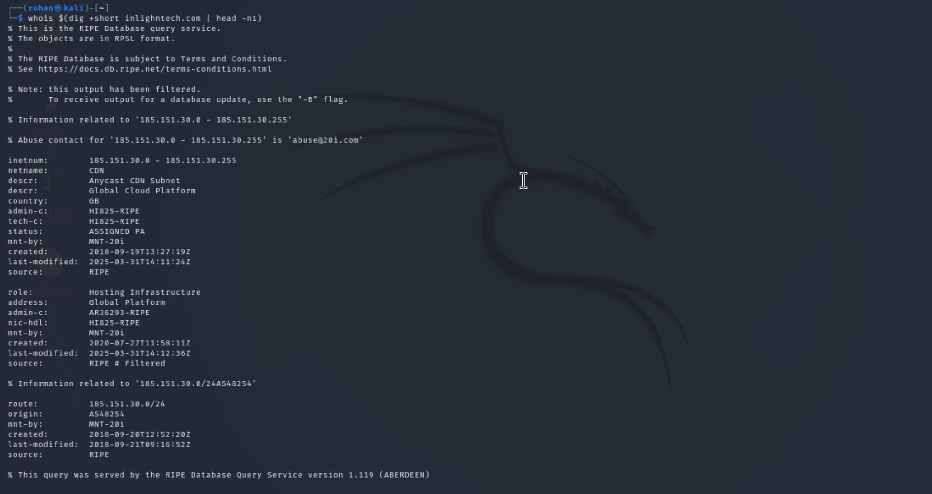

## **2. Subdomain Enumeration**

* **Objective**

The goal of subdomain enumeration is to discover all publicly available subdomains related to the target domain (*inlighntech.com*). This helps identify additional assets or entry points that may be overlooked but still belong to the same organization.

### **Tools Used**

* **Sublist3r** – Fast subdomain enumeration using online search engines.
* **Amass** – Advanced subdomain discovery using multiple data sources.
* **Assetfinder / Subfinder** – Lightweight alternative tools for quick passive enumeration.

### **Commands Executed:**

|  |
| --- |
| **sublist3r -d inlighntech.com****amass enum -passive -d inlighntech.com****subfinder -d inlighntech.com** |

**Findings:**

|  |  |  |
| --- | --- | --- |
| **Subdomain** | **Source Tool** | **Notes** |
| inlighntech.com | Subfinder | Main domain |
| [www.inlighntech.com](http://www.inlighntech.com/) | Sublist3r, Subfinder | Primary web service |
| ns1.stackdns.com – ns4.stackdns.com | Amass | DNS servers |
| smtp.google.com | Amass | MX record (mail service) |

**Total Unique Subdomains Identified:** 2  
 *(No additional subdomains were exposed through public sources**.)*

**Interpretation:**  
 The subdomain enumeration results reveal a **minimal public attack surface**, indicating that *inlighntech.com* maintains a simple DNS structure.

* The **primary web domain** ([www.inlighntech.com](https://www.inlighntech.com)) appears to be the only publicly hosted service.
* The **MX record** points to **Google’s SMTP servers**, suggesting that email is managed via Google Workspace.
* **Name servers** (ns1–ns4.stackdns.com) belong to StackDNS, consistent with WHOIS data from the previous section.

No testing or brute-force enumeration beyond passive reconnaissance was conducted, following ethical boundaries.

Screenshot Evidence:

*Figure 2.1* – Sublist3r output showing discovered subdomain.

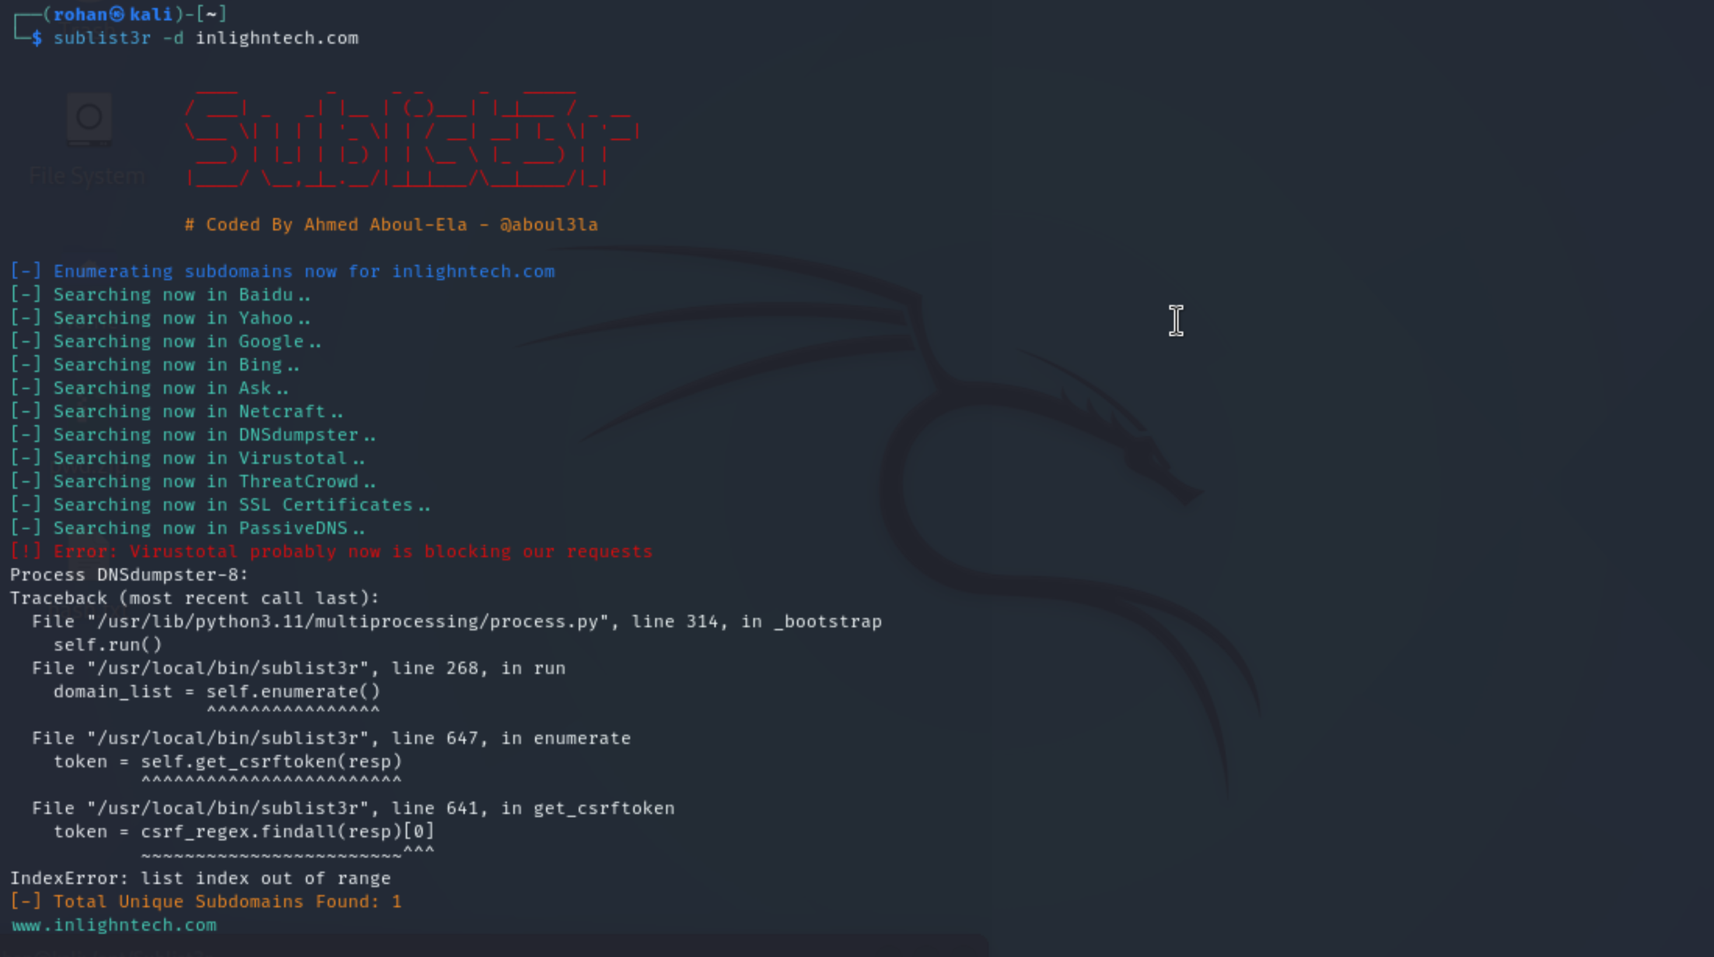

*Figure 2.2* – Amass output displaying MX and NS records.

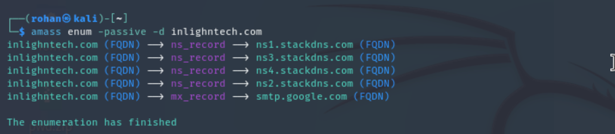

*Figure 2.3* – Subfinder output confirming subdomains and total count.

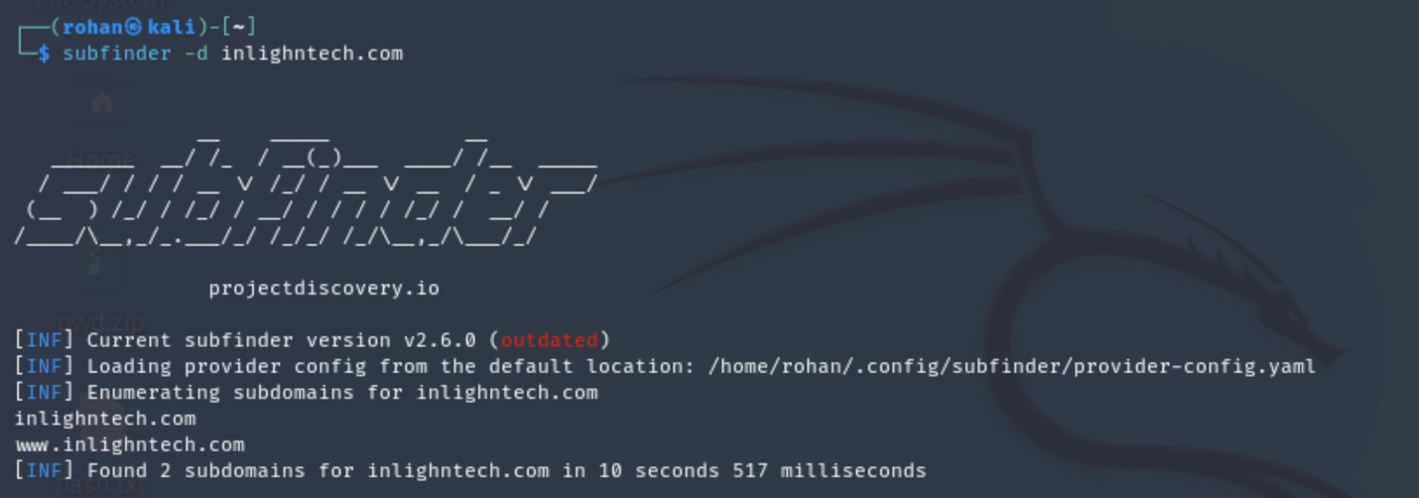

**3. Subdomain Enumeration:**

**Objective:**

To gather and analyze the DNS records for the target domain (*inlighntech.com*) in order to understand its network configuration and external dependencies.

**Commands Executed:**

|  |
| --- |
| * dig inlighntech.com any |

### **Findings**

|  |  |  |
| --- | --- | --- |
| **Record Type** | **Value** | **Description** |
| **A** | 185.151.30.222 | IPv4 address of the main web server. |
| **AAAA** | 2a07:7800::222 | IPv6 address corresponding to the same host. |
| **MX** | smtp.google.com (Priority: 1) | Mail is handled via Google’s SMTP servers (likely Google Workspace). |
| **NS** | ns1.stackdns.com, ns2.stackdns.com, ns3.stackdns.com, ns4.stackdns.com | Name servers hosted by StackDNS, responsible for DNS management. |
| **TXT (Verification)** | google-site-verification=SlijmfSYACbVWrV8CBwMhYA3grpi4LHyzSDhOVxsFmo | Indicates Google Search Console domain verification. |
| **TXT (SPF Record)** | v=spf1 include:spf.stackmail.com a mx -all | Specifies which mail servers are authorized to send emails for this domain (helps prevent spoofing). |
| **SOA** | ns1.stackdns.com / hostmaster.stackdns.com | Start of Authority record defining primary name server and zone configuration. |

### **Interpretation**

The DNS records confirm that the domain *inlighntech.com* is hosted at **IP address 185.151.30.222** (IPv4) and **2a07:7800::222** (IPv6).  
 The **MX record** points to **Google’s SMTP service**, which implies that the organization uses **Google Workspace** for email management.

The **TXT records** reveal two important configurations:

* **Google site verification**, which confirms ownership for SEO or analytics purposes.
* **SPF (Sender Policy Framework)**, which defines trusted mail servers and helps reduce email spoofing risks.

The **NS and SOA records** indicate DNS services are provided by **StackDNS**, matching earlier WHOIS data.  
 No anomalies or unauthorized entries were observed.

Figure 3.1: Output of dig inlighntech.com any showing DNS record details.

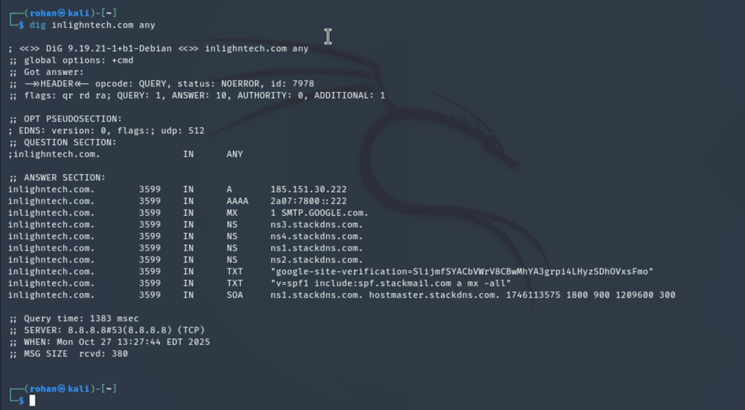

Figure 3.2: Highlight of TXT and MX records indicating mail configuration.

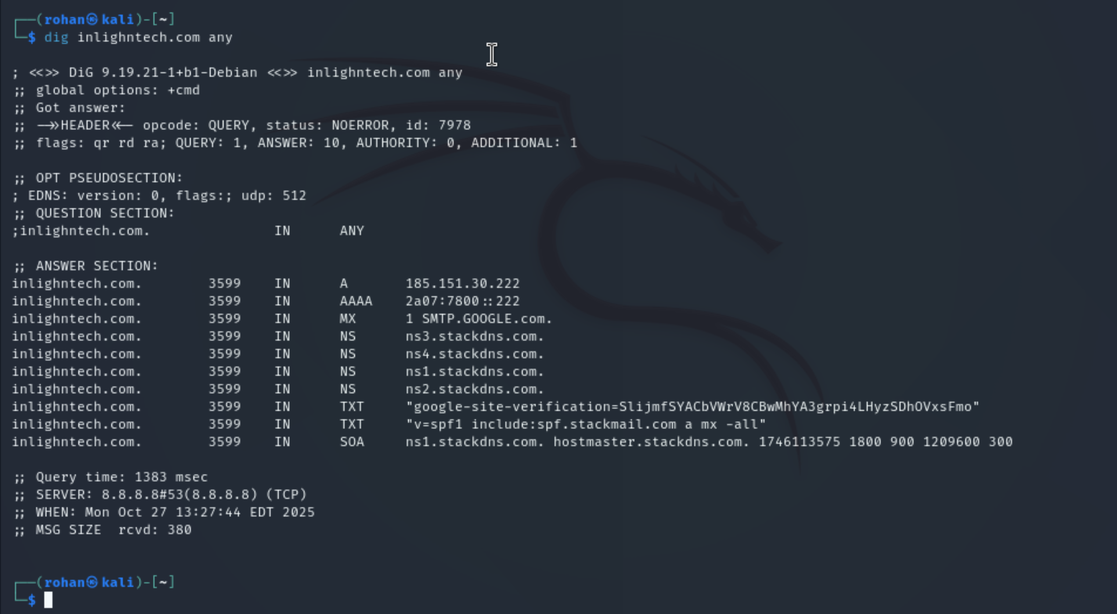

## **4. Technology Fingerprinting**

Objective:

To identify and analyze the technologies, frameworks, plugins, and infrastructure supporting the target website (*inlighntech.com*). Understanding this stack helps assess architecture, hosting choices, and security posture.

### **Tools Used**

* **WhatWeb** – Command-line fingerprinting tool for quick server-side detection.
* **Wappalyzer** – Browser extension for identifying front-end and back-end technologies.
* **BuiltWith** – Online profiling tool for full stack visibility (server, CMS, analytics, and email).
* **curl** – To inspect HTTP response headers.

### **Commands Executed**

* whatweb inlighntech.com
* curl -I inlighntech.com  
  *(Wappalyzer and BuiltWith scans performed in browser**.)*

### **Findings Summary**

|  |  |  |
| --- | --- | --- |
| **Category** | **Detected Technology** | **Details / Version** |
| **Web Server** | Apache HTTP Server | Primary server software running on 20i hosting. |
| **Backend Language** | PHP 8.3.25 – 8.3.26 | Server-side scripting language for dynamic content. |
| **Database** | MySQL | Backend database used by WordPress CMS. |
| **CMS** | WordPress 6.7–6.8 | Core content management platform. |
| **WordPress Plugins** | Elementor, Elementor Pro, WooCommerce, Formidable Forms, Redux Framework, Yoast SEO (Free + Premium), JoinChat (WhatsApp Me) | Enables page building, e-commerce, form handling, SEO optimization, and live chat. |
| **Theme** | DigiCove | WordPress theme used for digital marketing-style layout. |
| **Frontend Libraries** | jQuery 3.7.1, jQuery UI, GSAP (3.11.4), Animate.css, core-js, Snap.svg, Swiper, Magnific Popup, WOW.js, Lightbox | Used for animations, responsive design, and enhanced user experience. |
| **SEO & Analytics** | Yoast SEO, Google Webmaster Tools, Open Graph Protocol, Sitelinks Search Box | Optimize content visibility and search ranking. |
| **Performance & CDN** | StackPath CDN, Priority Hints | Caching and content delivery for faster load times. |
| **Security & Certificates** | HTTPS enforced, SSL by Default (Let’s Encrypt) | Ensures encrypted data transmission. |
| **Email & DNS** | Google Apps for Business (G Suite), SPF, DMARC Quarantine policy | Secure email authentication and spam protection. |
| **Mapping Integration** | Google Maps, Google Maps API | Embeds map services into the website. |
| **Fonts & Icons** | Google Fonts, Font Awesome, Twitter Emoji (Twemoji) | Enhance typography and visuals. |
| **Hosting & Infrastructure** | 20i Web Hosting (UK) with 20i DNS | Confirms UK-based hosting with IPv6 support. |
| **Mobile Optimization** | Viewport Meta Tag, iPhone Compatibility, Apple Web Clips Icon | Ensures responsive mobile layout. |
| **Social Media Presence** | LinkedIn, Instagram, YouTube | Mentioned in metadata; integrated via social links. |
| **Schema Markup** | Organization Schema | Structured data for SEO and Google indexing. |

### **Interpretation**

The combined fingerprinting data shows that *inlighntech.com* is a **WordPress-based website** built using **Apache** and **PHP 8.3**, with **MySQL** as the backend database.  
 The integration of plugins like **Elementor Pro**, **WooCommerce**, and **Yoast SEO Premium** indicates a feature-rich e-commerce and marketing-oriented design.  
 The site is **secured via Let’s Encrypt SSL**, uses **StackPath CDN** for caching and performance, and follows **SPF + DMARC** policies for email security.  
 Front-end frameworks such as **GSAP**, **Animate.css**, and **jQuery** enhance interactivity and visual animations, while tools like **Google Webmaster** and **Open Graph** improve discoverability and social integration.

Overall, the website demonstrates a **modern, secure, and mobile-optimized stack**, suitable for a professional online business platform.

**Figure 4.1:** Output of **whatweb** displaying Apache, PHP, and WordPress detection.

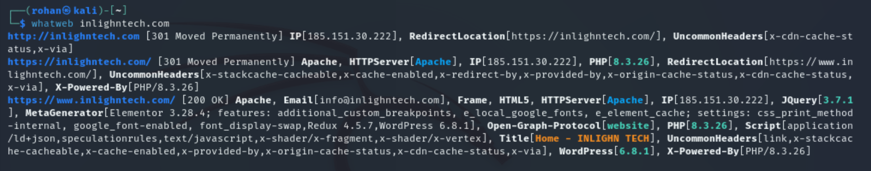

**Figure 4.2:** Wappalyzer scan showing CMS, plugins, and frameworks.

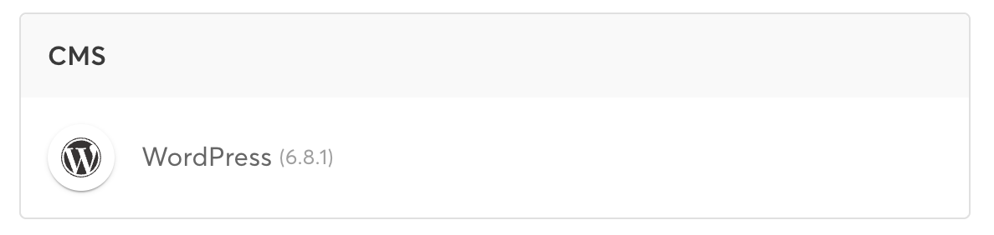

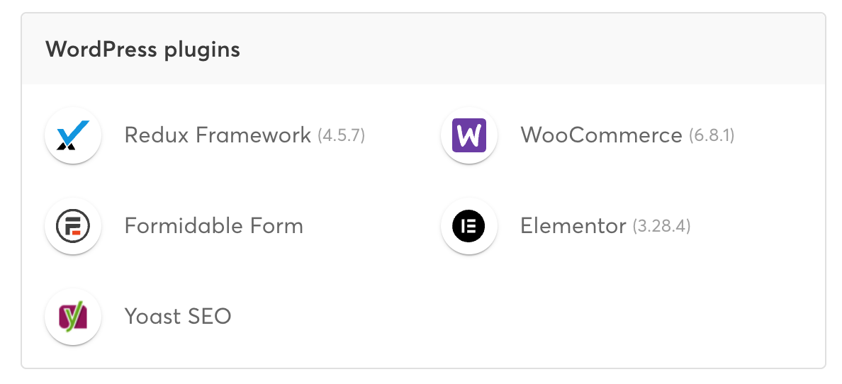

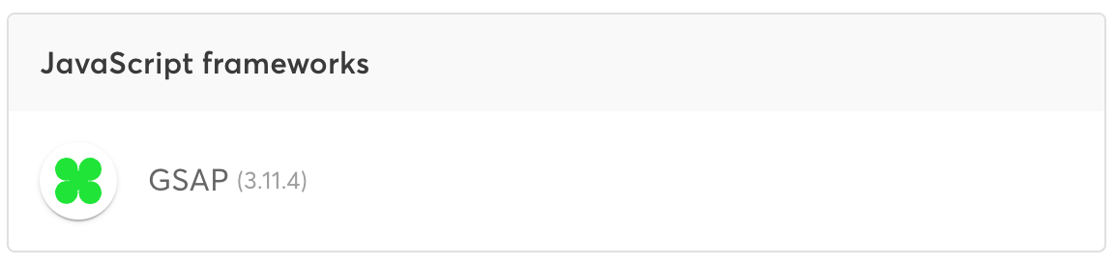

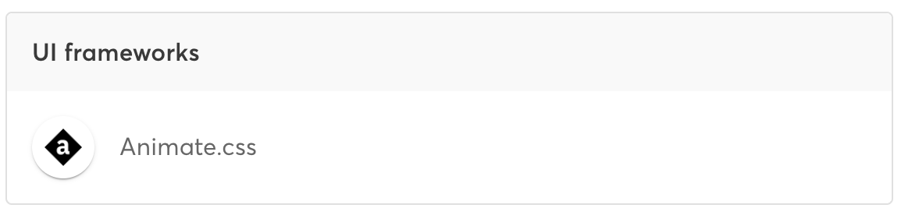

**Figure 4.3:** BuiltWith results confirming hosting provider, CDN, and security certificates

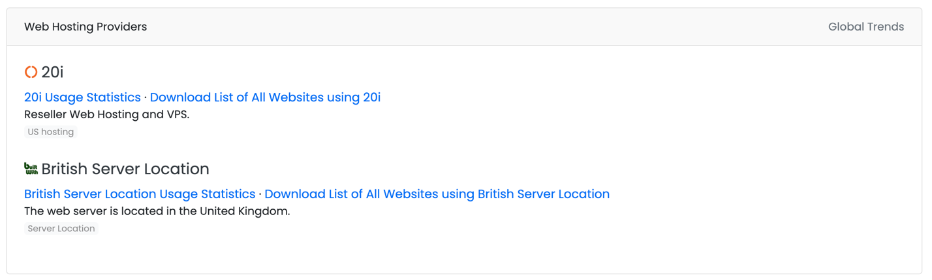

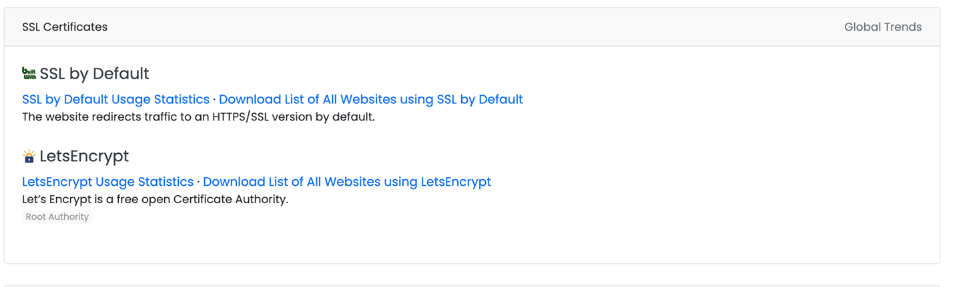

**5. Directory and File Discovery**

**Objective:**  
 To identify publicly accessible directories or files on the target website (*inlighntech.com*) that might reveal sensitive data or administrative areas. This is a key part of information gathering in web security assessments.

### **Tools Used**

* **DIRB** – Directory brute-force tool preinstalled on Kali Linux.
* *(Optional alternative: Gobuster)*

### **Command Executed**

dirb <https://www.inlighntech.com> /usr/share/wordlists/dirb/common.txt

### **Findings**

The scan completed successfully using **4,612 dictionary words** from the default wordlist.  
 The following directories and pages were discovered (HTTP **301 redirects** indicate valid locations):

|  |  |  |
| --- | --- | --- |
| **Directory / Page** | **Status Code** | **Description** |
| /about | 301 | Common site information page |
| /contact & /contact-us/ | 301 | Contact and inquiry form |
| /courses/ | 301 | Publicly accessible courses page |
| /api | 301 | Possible API endpoint (redirects, not accessible directly) |
| /app | 301 | Application or subdirectory placeholder |
| /bin, /log, /arch | 301 | System-related paths, likely blocked or redirected |
| /background, /business, /content | 301 | Site content and media directories |

**Total directories discovered:** 72  
 **Final accessible directories of interest:** /contact-us/, /courses/, /about/

### **Interpretation**

The results indicate that *inlighntech.com* has a **standard WordPress site structure**.  
 Most discovered paths redirect (HTTP 301) — meaning directory listing is disabled, and the site enforces canonical routing.  
 However, the presence of directories like /api and /app shows that there may be **backend integration points**, though no direct access is permitted.

The discovered **/contact-us/** and **/courses/** directories align with legitimate public pages, suggesting proper configuration and no sensitive files exposed.

The **“Too many connection errors”** message near the end is common in HTTPS scans; it indicates the tool hit rate limits or temporary network timeouts, not a security issue.

**Figure 5.1:** DIRB scan progress showing valid directory hits.

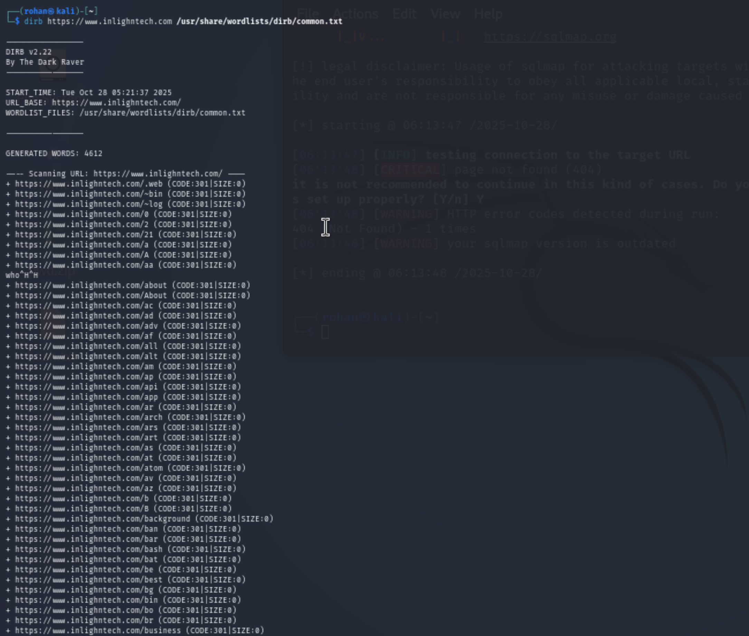

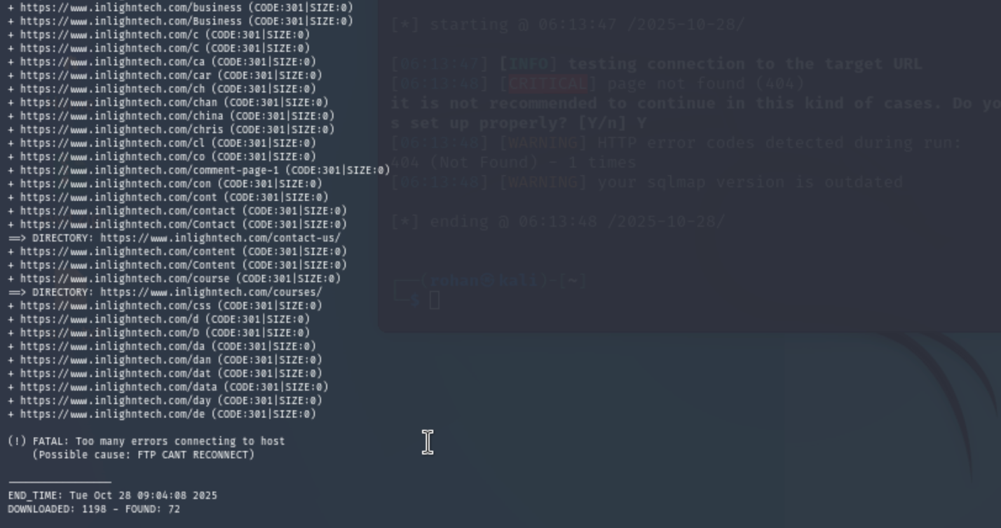

6. Open Ports and Services Enumeration

### **Objective**

The goal of this section is to identify which network ports are open on the target server and determine which services or applications are running on those ports. This helps assess what entry points an attacker might use and confirms whether only legitimate services (like web hosting) are exposed.

### **Tasks You Performed**

1. **Selected scanning tool:** You used **Nmap**, a popular network mapper for port scanning and service detection.
2. **Attempted a full port scan:**
   1. Command: nmap -sS -Pn -p 1-1000 185.151.30.222
   2. Result: “Requires root privileges” → because SYN scans (-sS) need sudo.
3. **Chose a focused, faster scan:**
   1. Final command used:
   2. sudo nmap -sS -Pn -p 22,80,443,8080 -sV -T4 185.151.30.222

**Purpose of flags:**

* -sS → SYN (stealth) scan for quick detection
* -Pn → skip host discovery (assume host is up)
* -p → specify ports (22 = SSH, 80 = HTTP, 443 = HTTPS, 8080 = proxy)
* -sV → detect service version
* -T4 → aggressive timing for faster results

### **Scan Output (Summary)**

|  |  |  |  |  |
| --- | --- | --- | --- | --- |
| **Port** | **State** | **Service** | **Version** | **Observation** |
| 22/tcp | closed | ssh | — | No SSH access on this host. |
| 80/tcp | open | http | nginx | Responded with “400 Bad Request”; indicates web server active. |
| 443/tcp | open | https | nginx | Encrypted web service (SSL); same nginx fingerprint. |
| 8080/tcp | closed | http-proxy | — | Not active on this IP. |

### **Technical Interpretation**

* **Web services detected:**  
   Ports 80 and 443 are open and running **nginx**, confirming the site is reachable via HTTP and HTTPS.
* **CDN/proxy layer:**  
   The headers like x-via: SIN1 and x-cdn-cache-status suggest the IP belongs to a **StackPath CDN or reverse proxy** that forwards requests to the origin server.
* **nginx vs Apache difference:**
  + Nmap probes the **edge server**, which reports nginx.
  + Earlier tools (WhatWeb, Wappalyzer) analyzed the **web content**, detecting WordPress + Apache at the backend.  
     → So: **edge = nginx (proxy)**, **origin = Apache (app server)**.
* **Security note:**  
   Only expected web ports are open; SSH and 8080 are closed. This minimizes external attack surface.

**Screenshots:**

* 1. Terminal output showing the open-port table.
  2. Cropped part of the fingerprint with “nginx” and “400 Bad Request”.
  3. Optional curl -I <https://inlighntech.com> headers to verify nginx/CDN.
  4. Caption example:

***Figure 6.1*** *– Nmap scan result showing open ports 80 (HTTP) and 443 (HTTPS) running nginx on 185.151.30.222.*

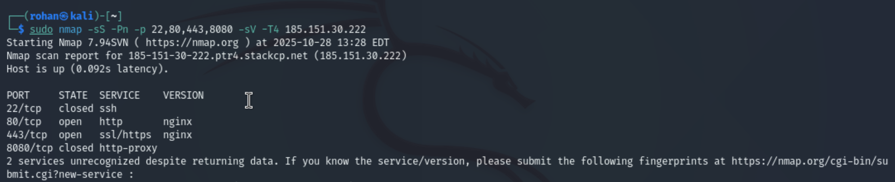

**7. Email Harvesting**

### **Objective**

Collect publicly available email addresses associated with the target domain **inlighntech.com** using passive / OSINT techniques. This helps assess the organization’s public communication footprint and potential exposure to spam or phishing.

**Commands / Methods Executed**

1. **theHarvester (multiple sources)**

theHarvester -d inlighntech.com -b all -l 200 > theharvester_inlighntech.txt

1. **theHarvester (Google-focused)**

theHarvester -d inlighntech.com -b google -l 200 > theharvester_google_inlighntech.txt

1. **Google dorking (manual, browser)** — used these queries:

site:inlighntech.com "@inlighntech.com"

site:inlighntech.com contact OR info OR support OR admin

1. **Certificate transparency check (crt.sh)**

curl -s "https://crt.sh/?q=%25.inlighntech.com&output=json" | jq .

### **Raw Findings (from tools & Google results)**

**Emails discovered (unique):**

* info@inlighntech.com — public contact email (site footer / contact page / Google results)
* hr@inlighntech.com — human-resources contact (found by theHarvester)
* prashant.raghav@inlighntech.com — individual email (found by theHarvester / site page)

**Additional evidence from your runs:**

* theHarvester reported AS48254 and the IPs 185.151.30.222 and 2a07:7800::222.
* theHarvester output explicitly listed the three emails above under [*] Emails found: 3.
* Your Google search screenshots show info@inlighntech.com appearing repeatedly in site results and in the contact page snippet.

### **Summary Table**

|  |  |  |
| --- | --- | --- |
| **Source** | **Email** | **Notes / Context** |
| theHarvester (all) | info@inlighntech.com | Main public contact (site footer & contact page) |
| theHarvester (all) | hr@inlighntech.com | HR contact found in indexed content |
| theHarvester (all) | prashant.raghav@inlighntech.com | Individual contact (page or certificate metadata) |
| Google Dork / Site | info@inlighntech.com | Visible in multiple site pages (Contact, footer) |

### **Interpretation & Risk Assessment**

* The domain exposes a **small set of public addresses**, primarily a general contact (info@...) and HR/individual emails.
* Having a public info@ address is normal for business contact; however, **employee-specific emails (like prashant.raghav@...)** increase targeted phishing risk if widely indexed.
* Presence of hr@inlighntech.com indicates an easily discoverable role-based mailbox — useful for legitimate contact but also a common vector for social-engineering attacks (recruitment scams, invoice fraud, etc.).
* DNS / SPF / DMARC checks performed earlier indicate some email protection (SPF and DMARC quarantine), which mitigates spoofing risk but does not prevent phishing to valid mailboxes.

### **Recommendations (brief, for report)**

1. Limit indexing of pages that expose employee email addresses (use robots.txt / noindex meta tags when appropriate).
2. Prefer role-based contact forms (site contact form) over publishing direct email addresses for employees.
3. Enforce and monitor DMARC/SPF/DKIM (already present — keep policies strict and monitor reports).
4. Educate staff to recognise phishing and use multifactor authentication on mailboxes.

**Evidence to Attach (figures & captions)**

**Figure 7.1:** Screenshot — theHarvester output showing [*] Emails found: 3 and the three email addresses.

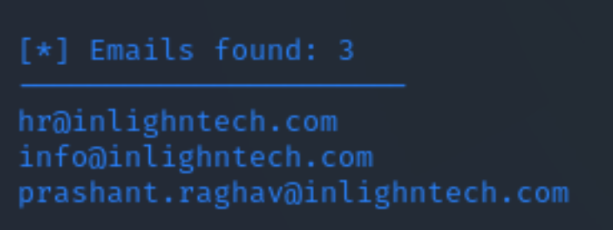

**Figure 7.2:** Screenshot — Google search results with info@inlighntech.com visible in site snippets.  
Caption: Google Dork result: site:inlighntech.com "@inlighntech.com" showing info@inlighntech.com on multiple pages.

 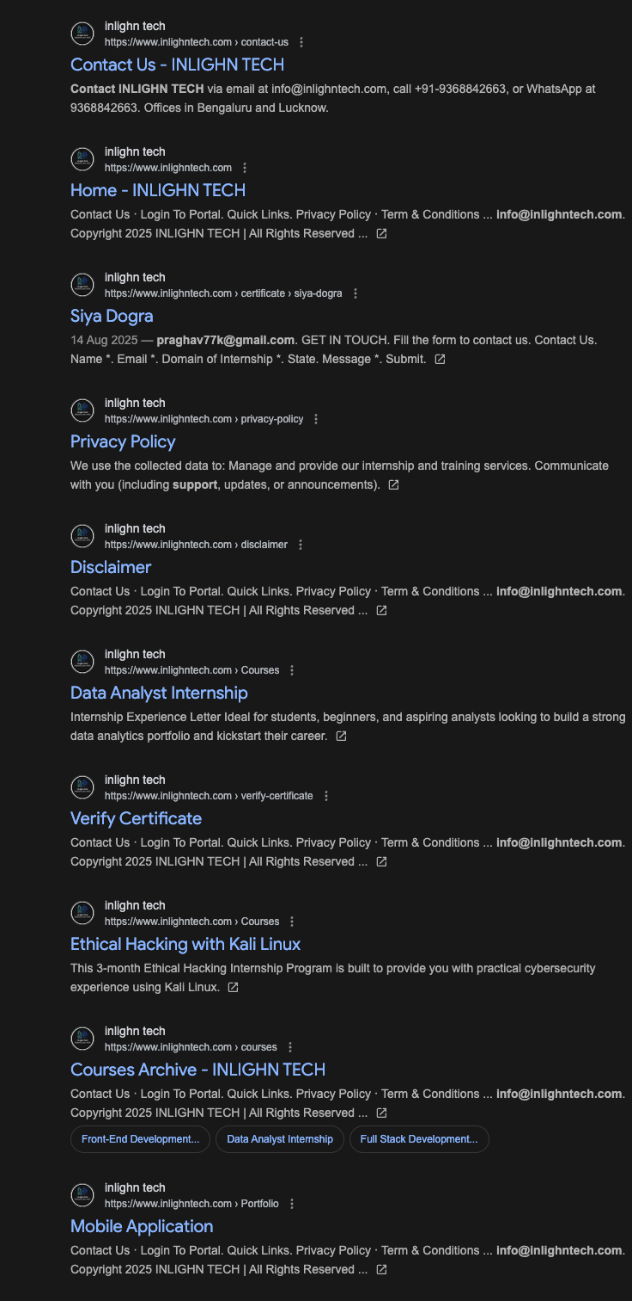

### **Conclusion**

Email harvesting for inlighntech.com returned **three publicly available addresses** (info@inlighntech.com, hr@inlighntech.com, prashant.raghav@inlighntech.com). The publicly visible info@ address is expected; the presence of role-based and individual address increases the importance of staff phishing awareness and continuing email authentication controls.

**8. SOCIAL MEDIA & PUBLIC DATA**

### **Objective**

Identify the target’s public presence on social media, business listings, developer sites, and certificate transparency logs to map the organisation’s external footprint and note any public data of interest.

* Extracted social links embedded on the homepage:
* curl -s https://www.inlighntech.com | grep -Eo 'https?://[^"]+(facebook|linkedin|instagram|twitter|youtube|wa.me|api.whatsapp|t.me|github)' | sort -u

(Output saved to Fig8_site_social_links.txt.)

* Dumped external links from the homepage for manual review:
* curl -s https://www.inlighntech.com | grep -Eo 'href="https?://[^"]+"' | sed 's/href="//' | sed 's/"$//' | sort -u

(Output saved to Fig8_all_external_links.txt.)

* Extracted Open Graph / social meta tags to find official profiles:
* curl -s https://www.inlighntech.com | egrep -i 'og:site_name|og:url|twitter:site|rel="me"|facebook|linkedin|instagram|youtube'

(Output saved to Fig8_meta_social.txt.)

* Certificate transparency check (crt.sh) to find issued certs / hostnames:
* curl -s "https://crt.sh/?q=%25.inlighntech.com&output=json" | jq .

(Saved as Fig8_crtsh.json / Fig8_crt_hosts.txt.)

• Manual Google searches / profile checks (LinkedIn, YouTube, Instagram, Maps) — screenshots uploaded by you (used as evidence).

### **Findings**

**Official social profiles & links discovered**

* LinkedIn company page: https://www.linkedin.com/company/inlighn-tech/.

Fig8_meta_social

* Instagram: https://www.instagram.com/inlighn_tech/?hl=en.

Fig8_all_external_links

* YouTube channel: https://www.youtube.com/@INLIGHNTECH (and a video link https://www.youtube.com/watch?v=w07el7UywbQ).

Fig8_all_external_links

These profile links were directly referenced in the site’s HTML / meta content.

Fig8_meta_social

**Other useful links found on the site**

* Courses, contact, privacy, terms, certificate verification pages (examples: /courses/, /contact-us/, /verify-certificate/). See extracted external links list.

Fig8_all_external_links

**Certificate transparency / hostnames**

* Several Let’s Encrypt certificates found for *.inlighntech.com and inlighntech.com (multiple issuance timestamps). This confirms active TLS provisioning and the exact hostnames in use.

Fig8_crtsh

**Summary of public exposure**

* The company maintains an active presence on **LinkedIn, Instagram, and YouTube** (official links embedded in the homepage).
* Site pages (Courses, Contact, Verify Certificate) provide business information and are indexed; these are normal for a company site.

Fig8_all_external_links

### **Interpretation & Risk Notes**

* **Visibility:** The organisation has a standard public footprint (company page + social channels). This supports marketing and recruitment but also increases the amount of public data attackers can use to profile employees or craft targeted phishing.
* **Certs / TLS:** Certificate records confirm the wildcard certificate usage for *.inlighntech.com, i.e., the site uses TLS correctly across subdomains.

Fig8_crtsh

* **No critical leaks found in the supplied outputs:** The extracted links and meta tags show marketing and contact pages only; no obvious sensitive information (API keys, credentials) appeared in the files you uploaded.

### **Screenshots / Evidence to Attach**

**Figure 8.1 — Site social links extract**: screenshot or paste of Fig8_site_social_links.txt showing LinkedIn / Instagram / YouTube references.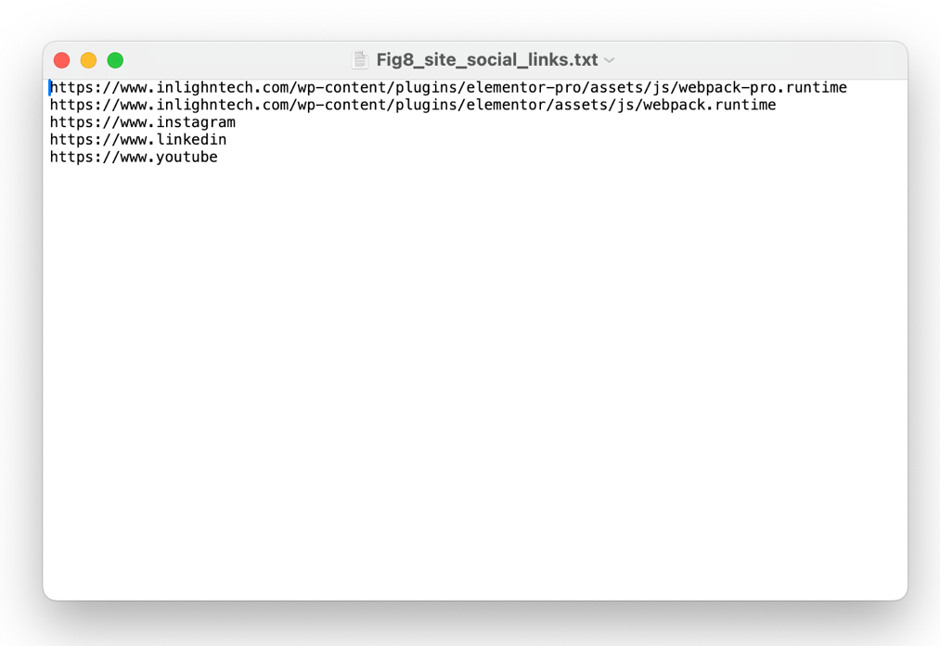

**Figure 8.2 — External links list**: screenshot of Fig8_all_external_links.txt showing pages like /courses/, /contact-us/, /verify-certificate/.

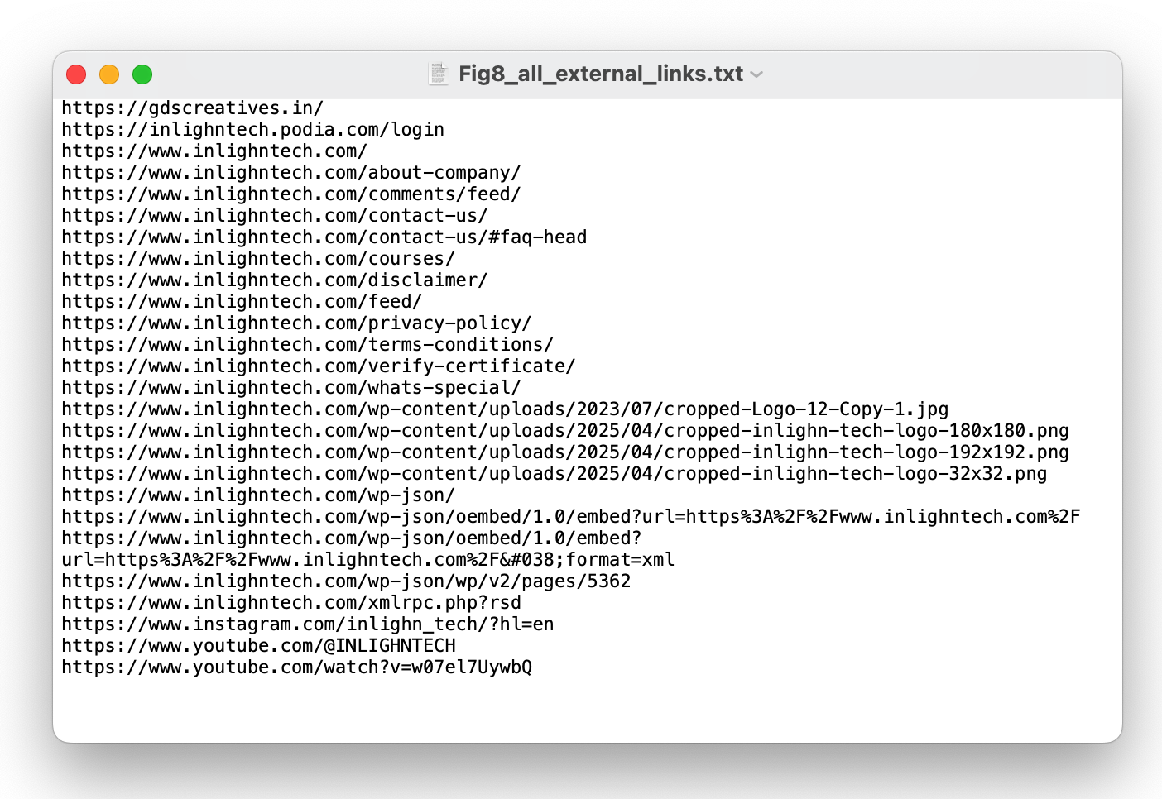

**Figure 8.3 — Meta tags / OG data**: screenshot or paste of Fig8_meta_social.txt showing og:site_name and the explicit social anchor tags.

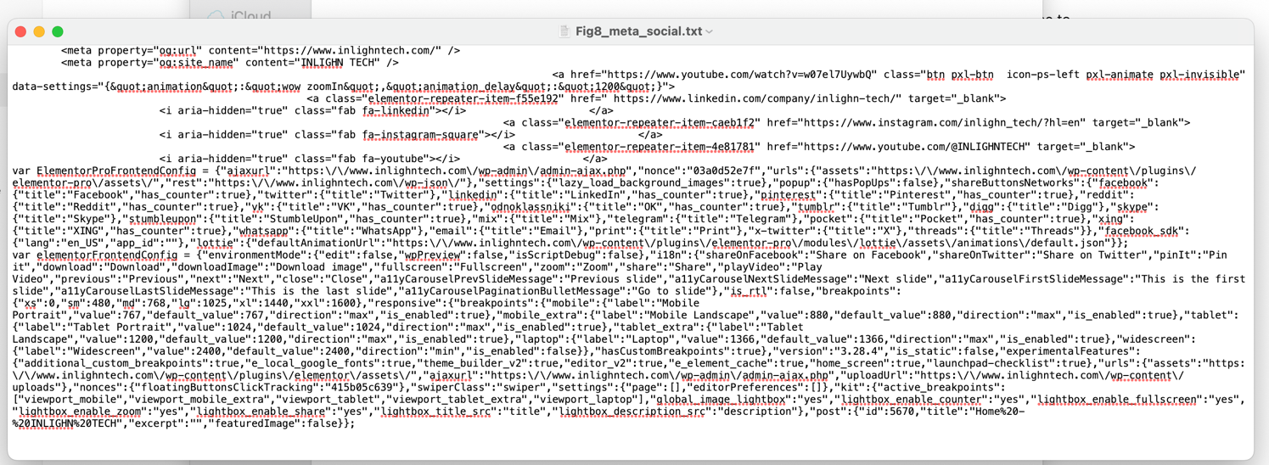

**Figure 8.5 — Google search / LinkedIn / Maps screenshots**: the screenshots you uploaded showing search results and profiles (attach these to the report).

* site:linkedin.com "Inlighn" OR "Inlighn Tech" OR "InlighnX"

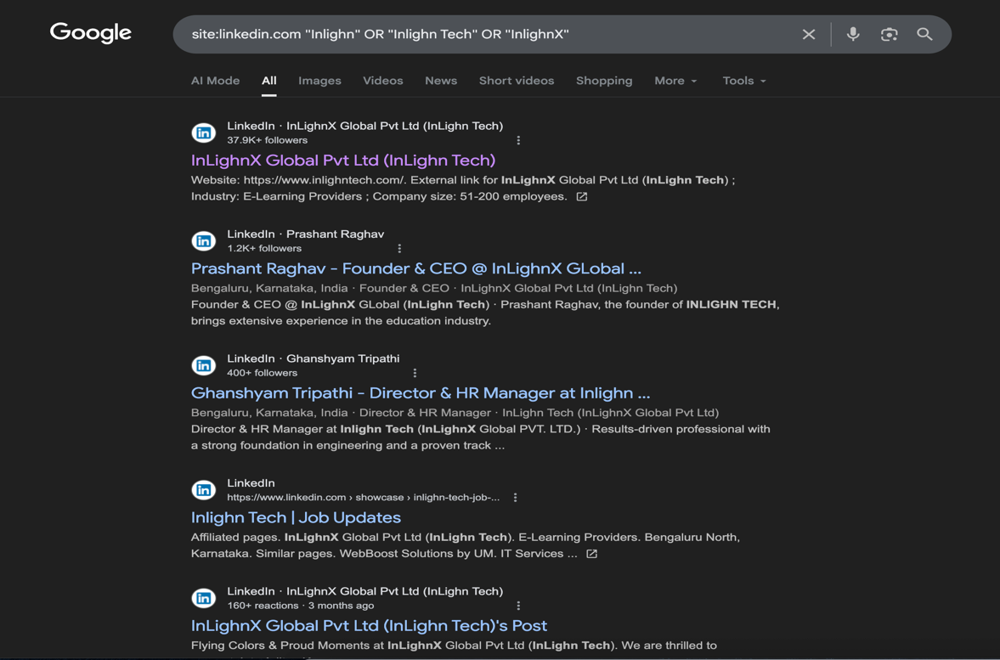

* site:facebook.com inlighntech

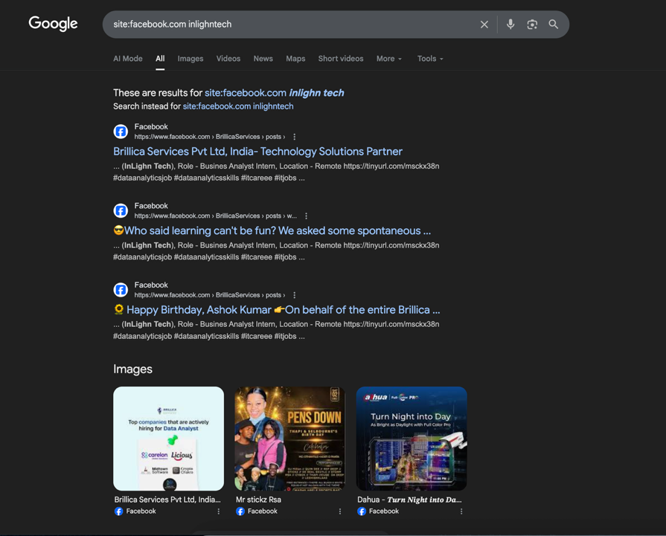

* site:instagram.com inlighntech

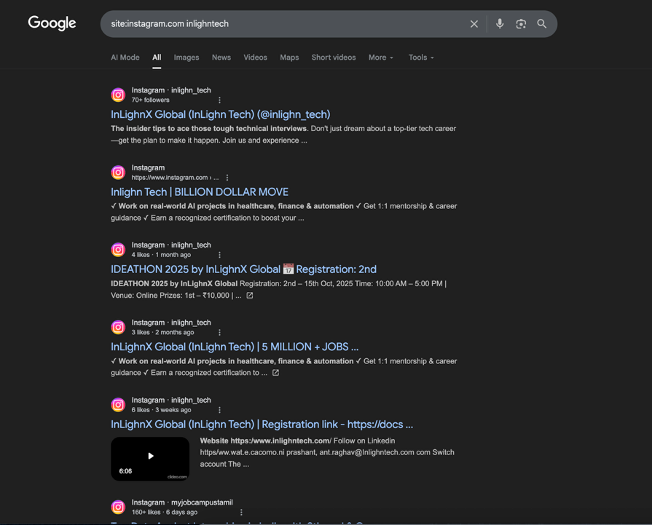

* site:youtube.com inlighntech

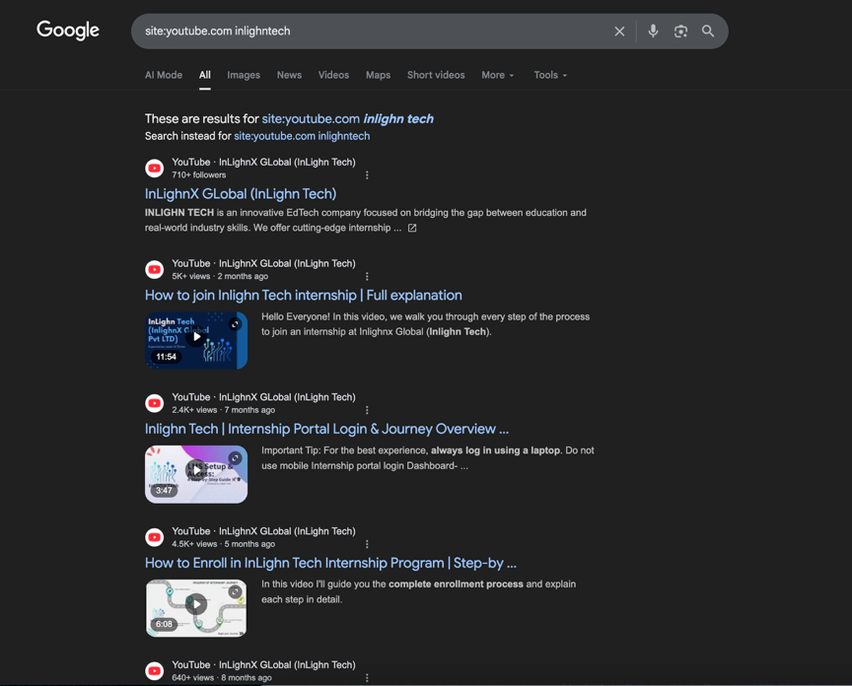

* site:google.com/maps "Inlighn" OR "INLIGHN"

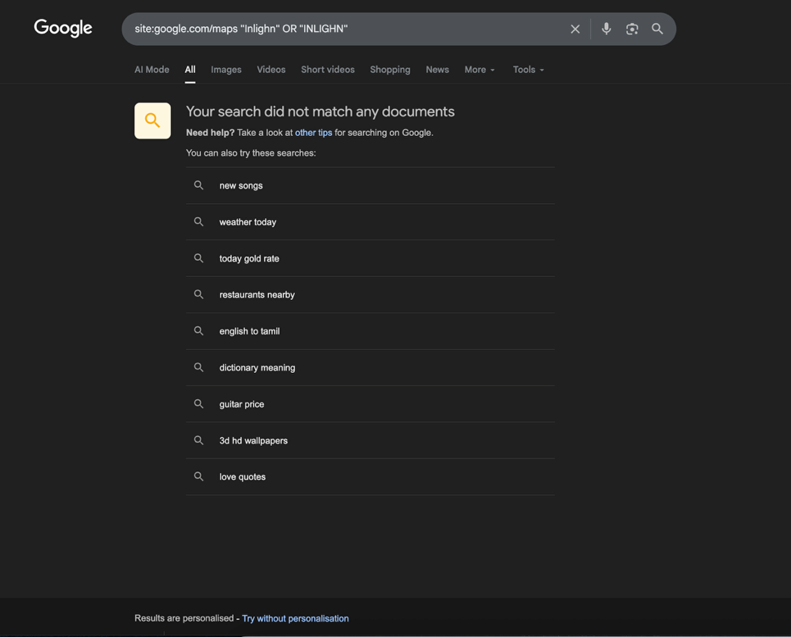

* site:glassdoor.com inlighntech

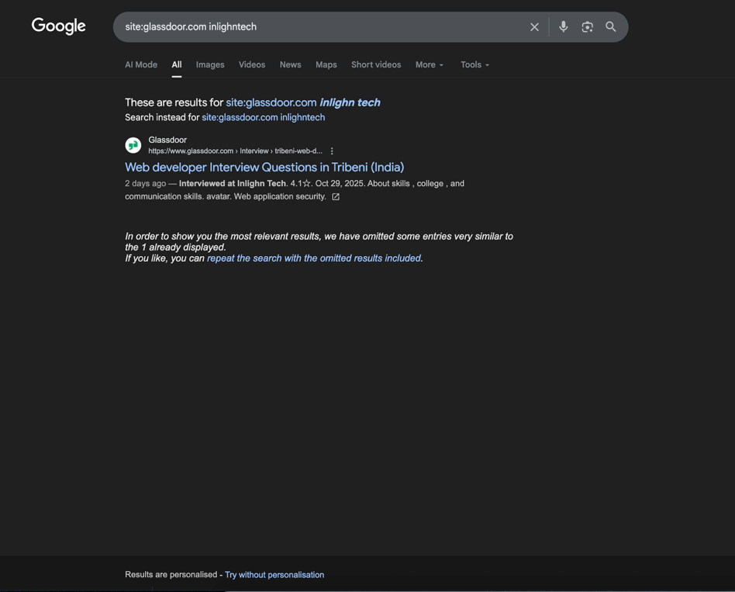

* **site:github.com inlighntech OR "InlighnX" OR "inlighn"**

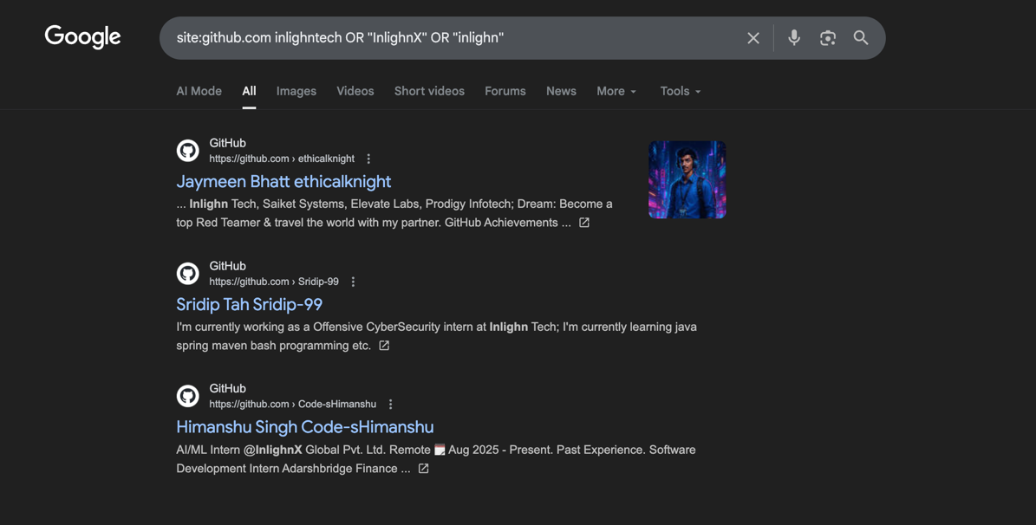

### **Conclusion**

Section 8 confirms that **INLIGHNTECH** has active, official social profiles (LinkedIn, Instagram, YouTube) linked from the homepage, normal business pages (courses, contact, certificate verification), and correctly issued TLS certificates for *.inlighntech.com. No exposed secrets were found in the provided outputs